DOCUMENTATION

**WBD End Project Evaluation  
Group : 12**

* *Implementation of REDIS:* Redis is an open-source, in-memory data structure store that can be used as a database, cache, and message broker.   
  - offers high performance, scalability, and reliability, making it a popular choice for modern web development projects.
* Redis was chosen for our project to address performance bottlenecks and improve scalability.
* in-memory nature allows for fast read and write operations, making it ideal for caching frequently accessed data.
* *Before REDIS vs After Redis:*

Before: Before integrating Redis, our application faced challenges related to performance and scalability. - Database queries were slowing down response times, especially during peak traffic periods.

After: Significant improvements in performance and scalability. - Response times decreased, and the application was able to handle higher loads without degradation.

1. Challenges

* Before Redis:

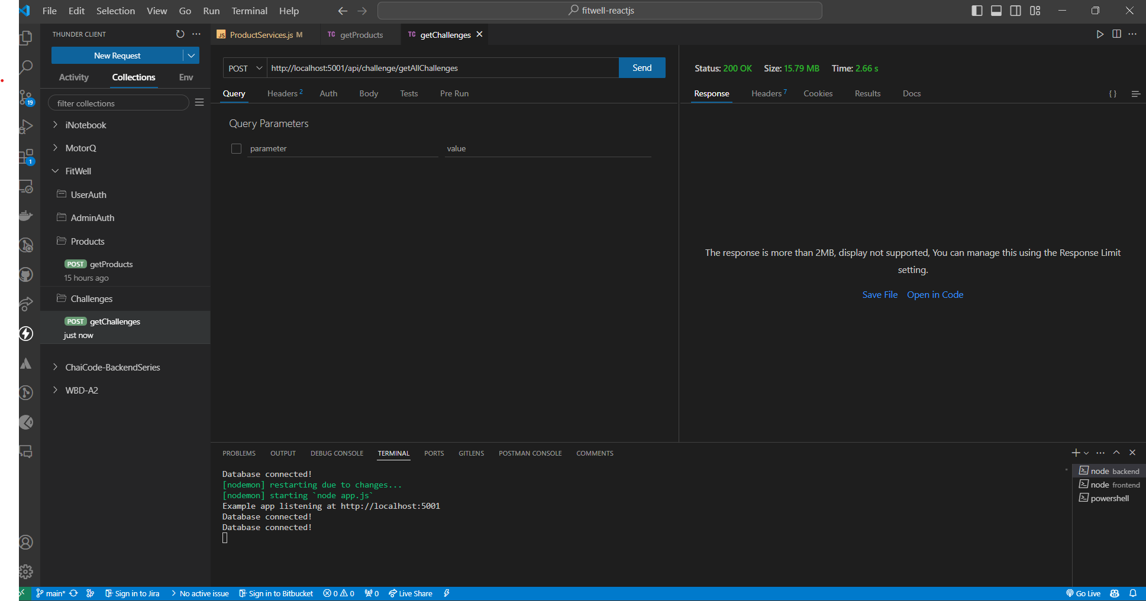

* After Redis

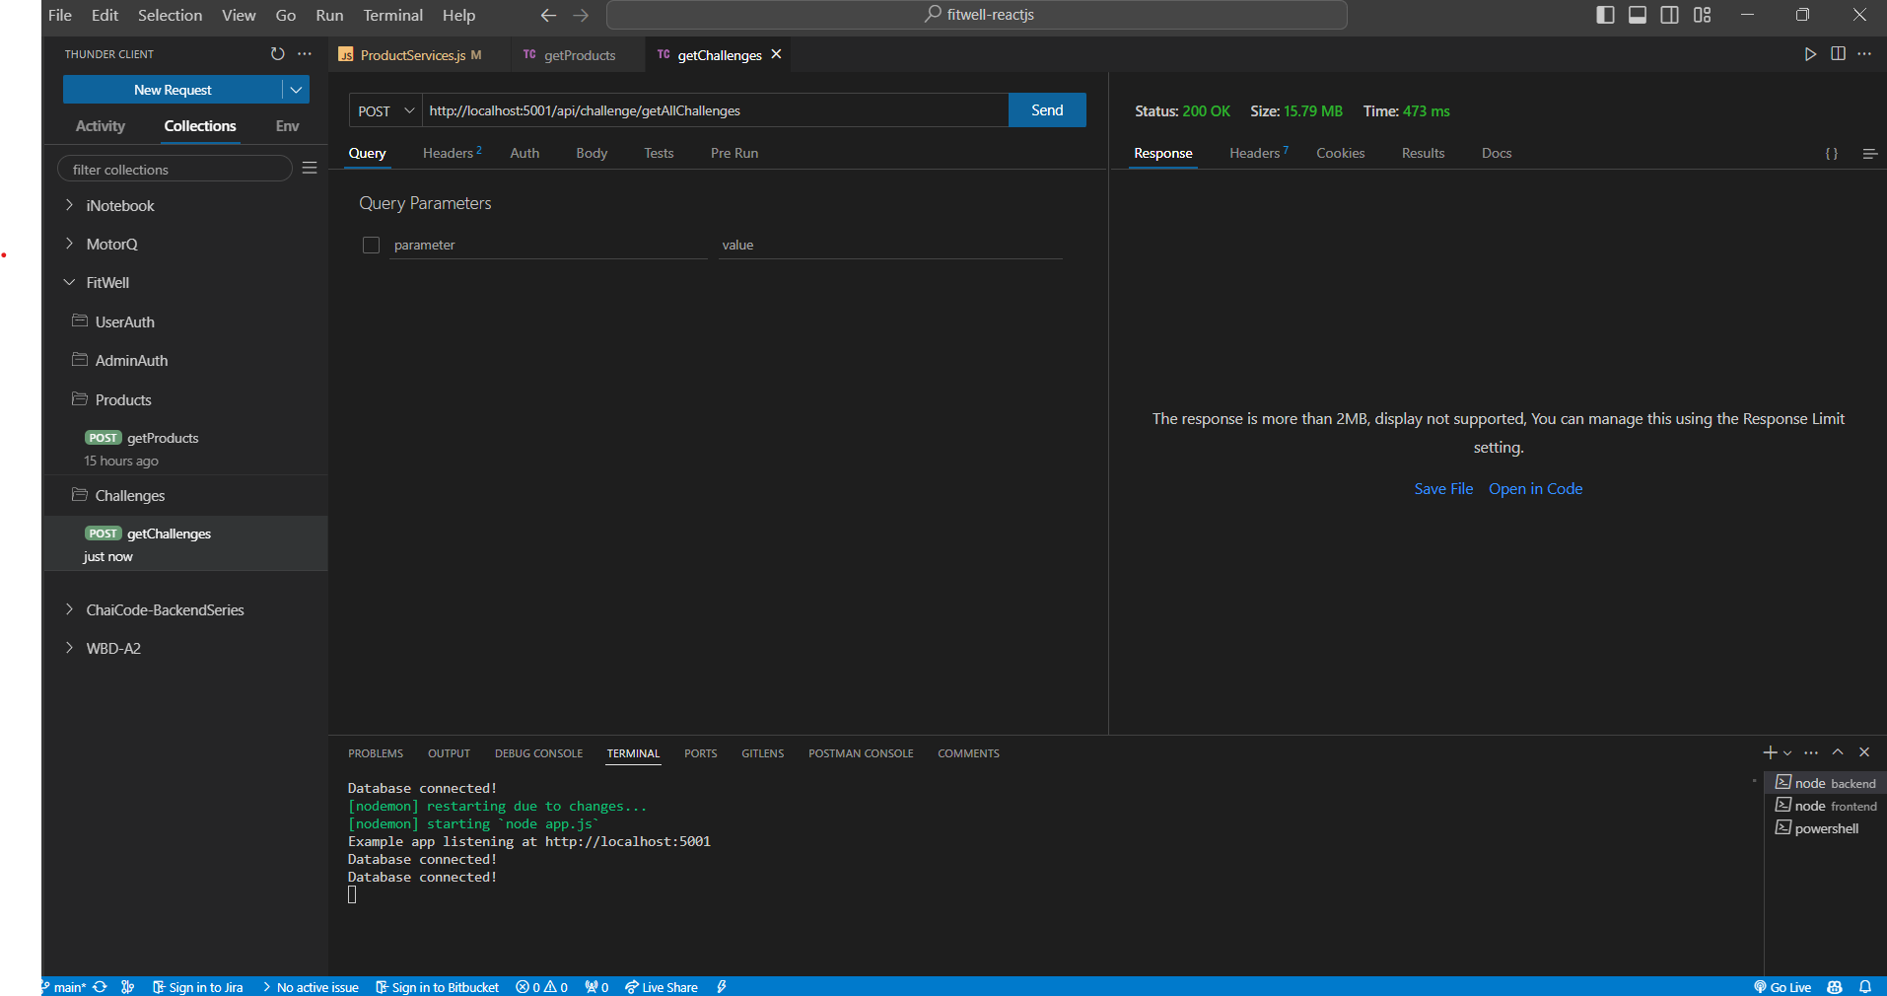

1. Products:

* Before Redis

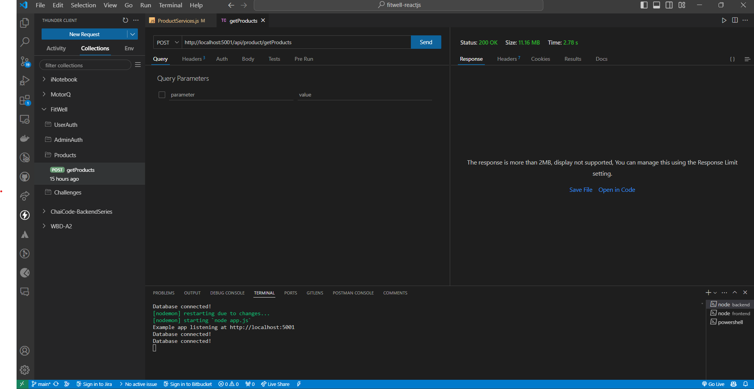

* After Redis

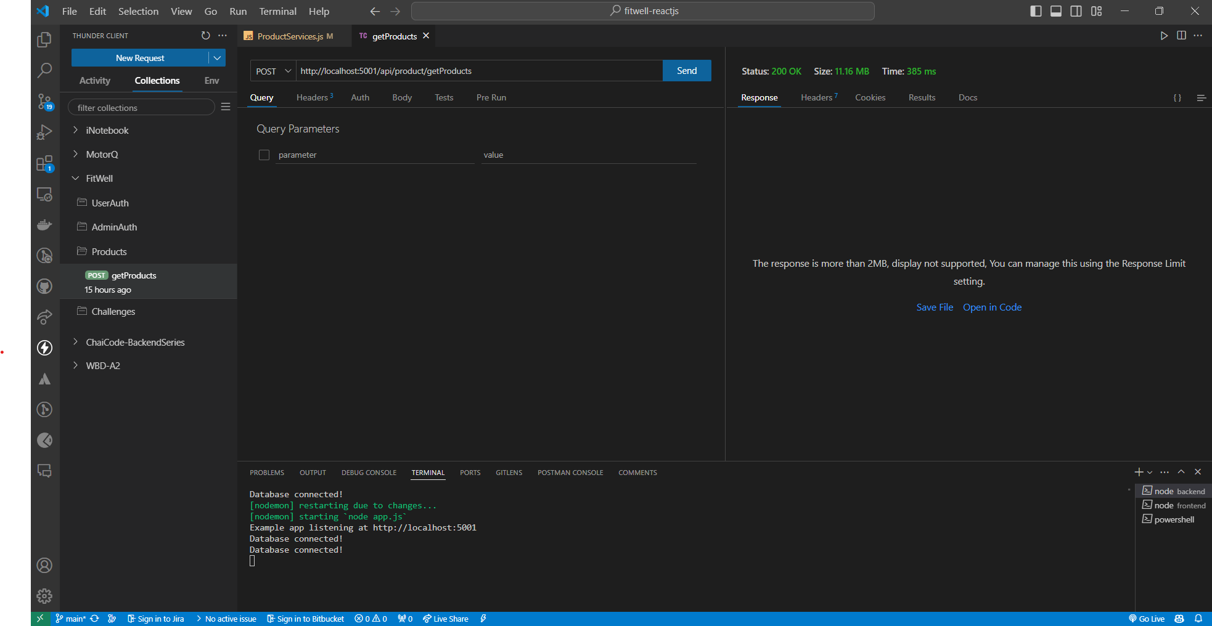

1. Workouts

* Before Redis

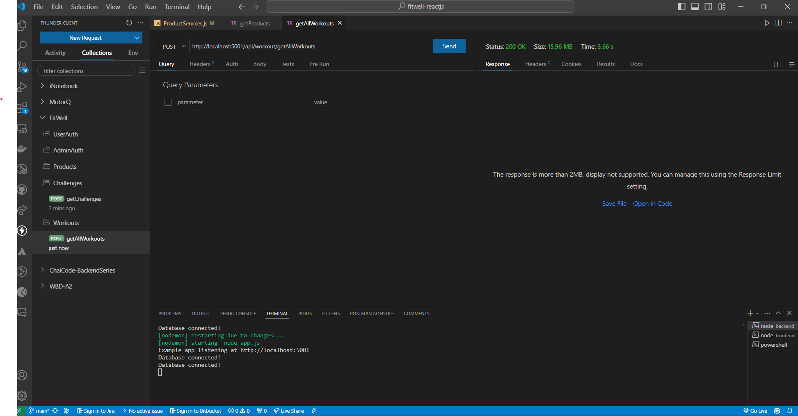

* After Redis

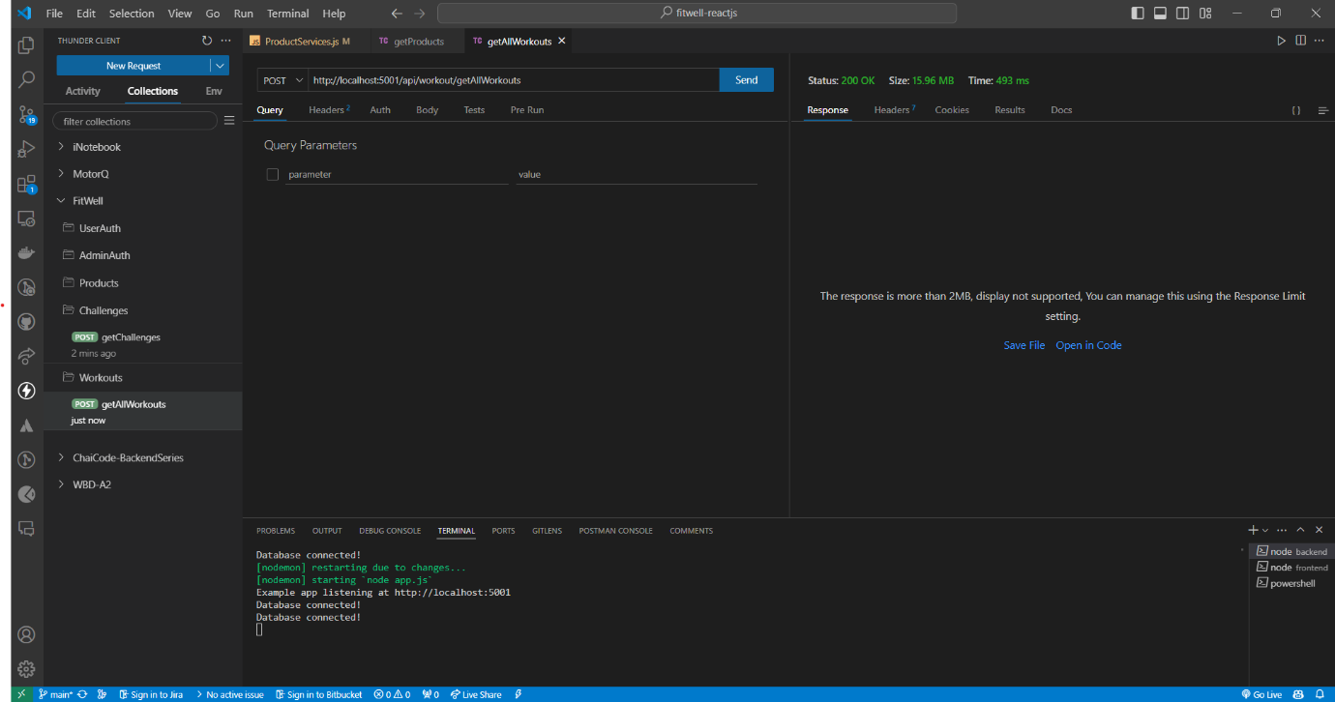

* INDEXING: refers to the process of organizing and storing data in a way that makes it faster and more efficient to retrieve. - commonly associated with databases and search engines.

Here's how indexing optimizes the process in the project:

The purpose of indexing the "users" column by "id" and "email" is to optimize data retrieval and improve overall performance in the web application. By creating indexes on these key fields, we aim to expedite user-related queries and enhance the user experience.

1. Product Indexing:

Field-

1) Name of product: - product name field is a crucial identifier for each product in the database. - creating index on the product name column, enables rapid retrieval of products based on their names. - facilitates efficient product searches and ensures quick access to relevant information.

2) Category: - category field categorizes products into distinct groups or types, allowing users to browse and filter products based on their preferences. - accelerates category-based queries and facilitates efficient navigation through product categories.

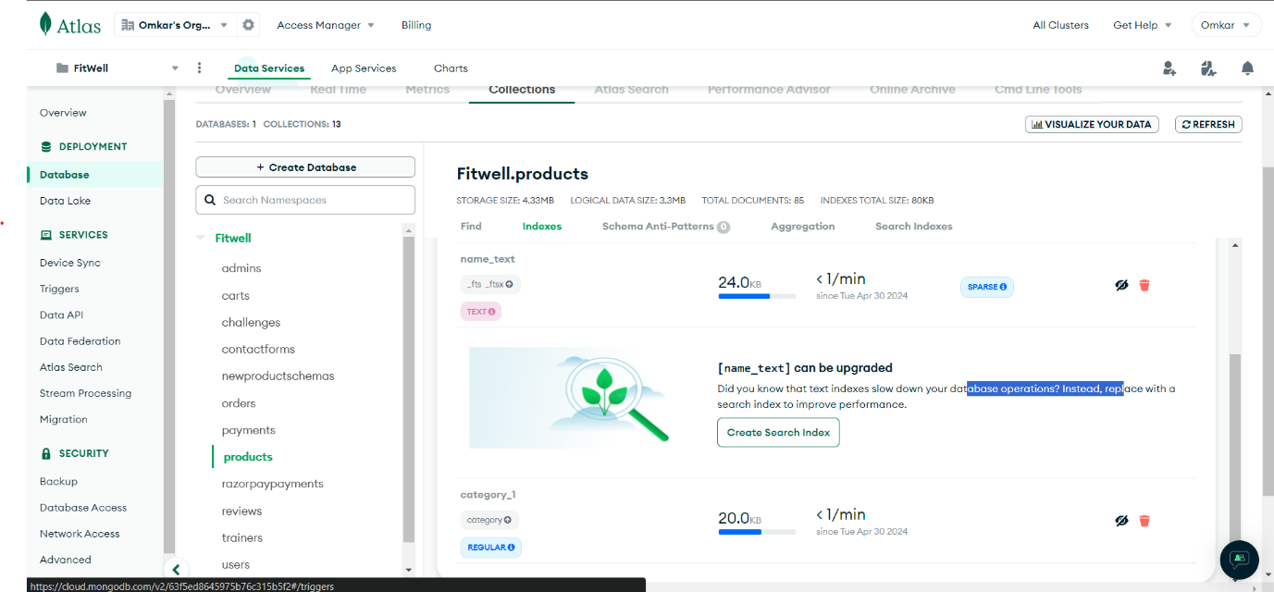

1. User Indexing:

Field-

1) Id: The ID field is primary key for each user record. - ensure fast retrieval of individual user records based on their unique identifier. - facilitates efficient lookup and retrieval operations for specific users.

2) Email: - The email field is a unique identifier for each user and is commonly used for authentication and communication purposes. - enable rapid retrieval of user records based on their email addresses. - streamlines operations such as user login, account verification, and email-based searches.

